Group Child Protection Policy

We will provide this policy on request at no cost, translated, in large print, in Braille, on tape or in another non-written format.

We can produce information on request at no cost in large print, in Braille, on tape or in another non-written format. We can also translate this into other languages. If you need information in any of these formats, please call us on 0800 479 7979 or email info@wheatley-group.com

Możemy, na życzenie, bezpłatnie przygotować informacje dużą czcionką, w alfabecie Braille’a, na taśmie lub w innym niepisanym formacie. Możemy je również przetłumaczyć na inne języki. Jeśli potrzebujesz informacji w którymkolwiek z tych formatów, zadzwoń do nas pod numer 0800 479 7979 lub wyślij e-mail na adres info@wheatley-group.com

Podemos produzir informações mediante solicitação e sem custos, em impressão grande, Braille, cassete ou noutro formato não descrito. Também podemos traduzi-las em outros idiomas. Se precisar de informações em qualquer um destes formatos, contacte-nos através do número 0800 479 7979 ou envie um e-mail para: info@wheatley-group.com

يمكننا إنتاج معلومات عند الطلب مجانًا مطبوعة بأحرف كبيرة أو بطريقة برايل أو على شريط أو بتنسيق آخر غير مكتوب. يمكننا أيضًا ترجمة هذا إلى لغات أخرى. إذا كنت بحاجة إلى معلومات بأي من هذه التنسيقات، فيرجى الاتصال بنا على 0800 479 7979 أو إرسال بريد إلكتروني إلى info@wheatley-group.com

در صورت درخواست، می‌توانیم اطلاعات را در چاپ بزرگ، خط بریل، روی نوار یا در فرمت غیرنوشتاری دیگری ارائه دهیم. همچنین می‌توانیم اطلاعات را به سایر زبان‌ها ترجمه کنیم. در صورت نیاز به اطلاعات بیشتر در هریک از این فرمت‌ها، لطفاً از طریق شمارۀ ‎0800 479 7979 با ما تماس بگیرید یا ایمیلی به info@wheatley-group.com ارسال کنید.

ہم درخواست پر معلومات کو بڑے حروف، بریل، ٹیپ پر یا کسی اور غیر تحریری صورت میں بغیر کسی لاگت کے مہیا کر سکتے ہیں۔ ہم اس کا دوسری زبانوں میں ترجمہ بھی کروا سکتے ہیں۔ اگر آپ کو ان میں سے کسی صورت میں یہ معلومات درکار ہوں تو برائے کرم ہمیں 7979 479 0800 پر کال کریں یا info@wheatley-group.com پر ای میل کریں۔

Approval body | Wheatley Group Board
Date of approval | March 2026
Review Year | Updated July 2022  Updated March 2026
Customer engagement required | Yes
Trade union engagement is required | Yes – For info
Equality Impact Assessment | Yes

Contents

1. Introduction 4
2. Policy Aims & Objectives 4
3. What is Child Protection? 5
4. Types of Abuse & Neglect 6
5. Our Role in Child Protection 9
6. A Personalised Approach to Child Protection 11
7. Measuring our Impact 12
8. Legislation & Strategic Drivers 12
9. Policy Review & Consultation 12
10. Policy Awareness & Training 13
11. Confidentiality & Data Protection 13
12. Equal Opportunities Statement 14
13. Complaints 14
Appendix 1 15
Appendix 2 16

Introduction

This policy is part of a suite of policies designed to safeguard and protect people. This Child Protection Policy outlines how we support children and young people at risk of harm and guides both customers and staff in understanding our responsibilities and the response process when we are concerned about a child.

This policy should be read in conjunction with the following policies:

- Adult Support & Protection;
- Multi-Agency Public Protection Arrangements (MAPPA);
- Suicide Risk; and
- Domestic Abuse.

Protecting children who are at risk from abuse or neglect is a shared responsibility. Everyone has a part to play, including social services, police, health, housing, and care organisations. Children should be supported to live free from harm.

The policy explains how we work with others to protect children at risk and support partner agencies whose responsibility it is to investigate where children may be at risk of abuse or neglect and provide support. As an organisation, we have a duty of care to report any concerns or disclosures about harm. Our staff play a key role in this by working directly with customers in their homes and communities. Through day-to-day contact, tenancy visits, repairs interactions, and routine customer conversations, staff are often well-placed to notice changes, pick up on early indicators of risk, and provide a safe environment for customers to share concerns. It is therefore our expectation that staff use these interactions to support the identification and reporting of harm, helping to safeguard our customers.

Staff will refer to this policy in the course of their work with Wheatley Group.

Policy Aims & Objectives

Our Aims

This policy has been designed to support staff and customers in understanding our approach to Child Protection. The policy aims to support staff to:

- understand Child Protection legislation;
- understand and recognise different types of harm and neglect;
- effectively support those at risk of or affected by harm;
- uphold the wellbeing and rights of all those who we deliver our services to; and
- effectively report concerns to statutory agencies (e.g. Police, social work, or health) when a child is at risk.

Our Objectives

For an effective approach to Child Protection to be embedded, our objectives are to:

- make sure our policy and supporting processes are clear, practical and easily accessible;
- ensure relevant staff are aware of their role and responsibilities and that these are clearly defined;
- provide training to relevant staff so they can confidently recognise and respond to signs of harm and neglect;
- build partnerships with agencies responsible for investigating Child Protection concerns and supporting children at risk through regular structured contact; and
- we will monitor Child Protection activity across the organisation to determine themes arising and ensure continuous improvement and strengthening of our approach through quality assurance of reports.

What is Child Protection?

The principles of the National Guidance for Child Protection in Scotland, (2021 – Updated 2023) state that every child deserves to live free from fear, harm, or abuse. Child Protection means recognising when a child might be at risk and taking steps to keep them safe. This includes the consideration, assessment, and planning of required actions. Police, social work, or health services evoke Child Protection procedures when they believe a child has been harmed or is at serious risk.

In Scotland, the definition of a child varies in different legal contexts; however, statutory guidance that supports the Children and Young People (Scotland) Act defines a child as anyone under the age of 18.

Where a young person between the ages of 16 and 18 requires support and protection, statutory services are required to consider which legal framework best supports each individual's needs and circumstances. This will ensure that these individuals do not fall between eligibility and service criteria due to an overlap in legislation between Adult Support & Protection and Child Protection.

In the context of the United Nations Convention on the Rights of the Child (Incorporation) (Scotland) Act 2024, a child means every human being below the age of 18. Where applicable, the United Nations Convention on the Rights of the Child (Incorporation) (Scotland) Act 2024 can give rise to rights and obligations relating to children and young people up to the age of 18.

When staff are concerned about a person at risk who they know or believe to be between the ages of 16 and 18, then a Child Protection referral should be completed. Statutory services will then determine whether the referral should be dealt with under child or adult protection processes.

In Scotland, the Child Protection Register refers to a confidential list of all children in a local authority who have been identified as being at risk of significant harm and are therefore subject to statutory oversight or intervention.

Any statutory agencies working with a child who is on the Register is aware of the urgent need for everyone to remain alert and act quickly to protect these children deemed at risk. Routinely, Wheatley Group staff would not be advised of a child being placed on the register unless this information was shared during case conferences, Multi-Agency Risk Assessment Conferences (MARAC), or at Disclosure Scheme Domestic Abuse Scotland (DS DAS) meetings, which our staff may attend. The Group Protection team will maintain a record of any child on the register whom we are aware of.

Types of Abuse & Neglect

Abuse and neglect are forms of child maltreatment. They may occur through direct actions or omissions that result in or fail to prevent significant harm. Abuse can happen within families, institutions, or, more rarely, by strangers.

All children have a fundamental right to care and protection. A child may require protection when their basic needs, such as food and warmth, are not met, or they may need protection from harm from other people.

The following categories of abuse and indicators are not exhaustive and should be used as guidance and not as a checklist.

Physical Abuse is the causing of physical harm to a child or young person. It may involve hitting, shaking, throwing, poisoning, burning, scalding, drowning, or suffocating. Physical harm can also happen when a parent or carer pretends a child is ill or deliberately makes them ill.

Possible signs of physical abuse:

- unexplained injuries or burns, particularly if they are recurrent;
- improbable excuses given to explain injuries;
- refusal to discuss injuries;
- untreated injuries or delay in reporting them;
- excessive physical punishment;
- arms and legs kept covered even in hot weather;
- fear of returning home;
- aggression towards others;
- running away; and
- administration of toxic substances.

Emotional Abuse is the persistent emotional neglect or ill-treatment of a child that causes severe and lasting harm to their emotional development. It may include:

- conveying to a child that they are worthless, unloved, or inadequate;
- valuing a child only insofar as they meet the needs of another;
- imposing age or developmentally inappropriate expectations; or
- causing the child to feel frightened, in danger, exploited, or corrupted.

Emotional abuse is often present in all forms of maltreatment, but it can also occur independently.

Possible signs of emotional abuse:

- low self-esteem;
- continual self-deprecation;
- sudden speech disorder/refusal to speak;
- fear of carers;
- severe hostility/aggression towards other children;
- significant decline in concentration span; and
- self-harm.

Sexual Abuse & Exploitation is any act involving a child in sexual activity for the gratification of another person, regardless of whether the child is said to have consented or assented. It includes:

- physical contact – penetrative or non-penetrative acts; or
- non-contact activities – exposure to indecent images, watching sexual acts, use of sexual language, or encouraging sexually inappropriate behaviour.

Child sexual exploitation is a form of sexual abuse where a person(s) of any age uses a power imbalance to force or entice a child into sexual activity in exchange for the sexual activity. The presence of perceived consent does not negate the abusive nature of the act.

Possible signs of sexual abuse or child sexual exploitation:

- sleep disturbances or nightmares;
- complaints of genital itching or pain;
- self-harm/eating disorders;
- unexplained pregnancy;
- acting in a sexually explicit manner;
- anxiety/depression/withdrawn;
- fear of undressing, e.g. for physical exercise;
- low self-esteem;
- inappropriate sexual awareness;
- running away;
- developmental regression; and
- lack of trust or over-familiarity with adults.
Online abuse is any type of abuse that happens on the internet. It can happen across any device that is connected to the web, like computers, tablets and mobile phones, and can happen anywhere online, including:
- social media;
- text messages and messaging apps;
- emails;
- online chats;
- online gaming; and
- live-streaming sites.

Children can be at risk of online abuse from people they know or from strangers. It might be part of other abuse which is taking place offline, like bullying or grooming. Or the abuse may only happen online.
A child or young person experiencing abuse online might:
- spend a lot more or a lot less time than usual online, texting, gaming or using social media;
- seem distant, upset or angry after using the internet or texting;
- be secretive about who they are talking to and what they’re doing online or on their mobile device; and
- have lots of new phone numbers, texts or email addresses on their devices.

Neglect is the persistent failure to meet a child’s basic physical and/or psychological needs, likely to result in serious impairment of the child’s health or development. It may involve:
- failing to provide adequate food, shelter, and clothing;
- not protecting the child from physical harm or danger;
- failing to ensure access to appropriate medical care or treatment; or
- ignoring or failing to respond to the child’s basic emotional needs.
In severe cases, neglect may result in a diagnosis of non-organic failure to thrive, where a child fails to reach normal growth or developmental milestones without a physical or genetic cause. In its extreme form, neglect can lead to malnutrition, lack of stimulation, and life-threatening consequences, especially for young children
Possible signs of neglect:

- constant hunger or inappropriate/erratic eating patterns;
- poor hygiene;
- constant tiredness;
- lack of adequate clothing;
- failure to seek appropriate/necessary medical attention; and
- unhygienic home conditions.

If a child says they’re being abused, even if there are no visible signs, take it seriously and report it immediately to the appropriate authorities.

The above list is not exhaustive. Our customer facing staff are best placed to be able to recognise and respond quickly to signs of harm and are supported to do so. We also work with other services to provide extra support to children and families when needed.

Our Role in Child Protection

Child Protection is everyone’s responsibility, not just those who work directly with children. Social Work and Police Scotland lead investigations, but they rely on others to report concerns.

As a housing and property management provider, we may not investigate abuse, but we play a vital role in recognising, responding to, and reporting any concerns. Customer facing staff are best placed to recognise and respond to concerns of abuse or neglect and are supported to do so. Appendix 1 sets out the process of staff are concerned that a child may be at risk of abuse or neglect.

Recognising signs of abuse or neglect

Our customer facing staff are well placed to identify children who may be at risk of abuse or neglect and are trained to remain alert and to identify concerns early.

We may learn that a child is at risk of abuse or neglect through:

- a parent or carer sharing a concern;
- information from someone else;
- observations by staff;
- insights from our customer information; and
- multi-agency meetings (e.g. Children’s Hearings).

Sometimes, a child may tell us directly. No matter how we find out, we must act appropriately and safely. If staff are unsure what to do, they should speak with their line manager or contact the Group Protection Team for support.

Responding to concerns of child abuse or neglect

Our customer facing staff will respond by reporting concerns and offering additional support to the child and family. There are clear processes in place to support staff to respond appropriately and report their concerns.

If someone shares a concern:

- we take it seriously, our role is to report, not investigate;
- we listen and avoid asking probing questions;
- we act quickly to offer help and refer to specialist services;
- we explain that the information must be passed on. This is linked to our requirement within legislation and our professional duty to act. Information will be shared in accordance with the rules for sharing personal data;
- we treat everyone with empathy and respect, and without judgement;
- we reassure the person they’ve done the right thing;
- if a child is in immediate danger, we call the emergency services. If there is any uncertainty, staff should speak with their manager or the Group Protection Team, and
- we report to statutory agencies (local authority, police or health) following the guidance on making reports below. This is linked to our requirement within legislation and the duty of care that we have to protect children from the risk of harm.

Reporting concerns of child abuse or neglect

If staff are worried about a child’s safety, it’s important to act quickly and follow the correct steps.

Where there is a safeguarding concern, the need to protect a child at risk will take precedence over data protection considerations. Data protection legislation must still be applied, but it must not be used as a barrier to sharing information that is necessary to prevent harm.

Under UK GDPR and the Data Protection Act 2018, personal data may be shared without consent where this is necessary to safeguard an adult at risk of harm. This includes situations where sharing is in the adult’s vital interests, is required to carry out a public task, or is necessary to fulfil duties under the Children and Young People (Scotland) Act.

Consent is not required where seeking it would increase risk, cause delay, or prevent timely intervention. In all cases, information sharing must comply with data protection principles: it must be lawful, necessary, proportionate, relevant, and shared securely. Further detail is provided in Section 11.

Use the standard reporting templates and specific process to contact the Local Authority where the child lives or call the local authority to report concerns. An example of a Child Protection referral form (CP1) can be found appended to this policy (appendix 2).
If a crime may have or has been committed, report it to Police Scotland by calling 101 or 999, depending on the urgency.
Staff should escalate any concerns to their line manager or to the Group Protection Team.
Contact details for all 32 council Child Protection Teams here:
https://www.childprotection.scot/useful-links/council-social-work/

If a neighbour or another person tells us a child is at risk, we’ll usually let the individual concerned know that we’re reporting it if it is appropriate to do so, unless it’s unsafe or not possible to do so. Staff should speak to their manager or the Group Protection Team if unsure.

Where there is a concern that a child is at risk of harm or neglect, consent does not need to be obtained to submit a referral to statutory agencies.

A Personalised Approach to Child Protection

At the heart of Child Protection guidance and procedures is ensuring the safety and wellbeing of children including protecting their human rights. We follow Scotland's national approach, Getting It Right for Every Child (GIRFEC), which means:

- offering the right help, at the right time, from the right people; and
- putting children’s rights and wellbeing at the centre of everything we do (where relevant).

Our approach to Child Protection includes consideration of human rights in accordance with the Human Rights Act 1998, and children’s human rights in line with the UNCRC (incorporation) (Scotland) Act 2024).

We tailor support to each family’s needs by offering a diverse range of services and making referrals to specialist services. We ensure that each interaction is personal as we recognise that there is no one-size-fits-all approach.

We provide advice and practical solutions to improve home security and personal safety, including safety products and guidance on online safety. Where appropriate, safety apps can be demonstrated to help families stay protected.

If a family feels unsafe in their current home, we will respond and offer a Housing Options interview and work with partners to explore safer housing solutions.

Alongside these measures, we offer wraparound support to families who need extra assistance, ensuring they have access to the right services and resources to meet their needs.

Measuring our Impact

We will measure our impact in Child Protection by:

- monitoring the number of Child Protection referrals submitted; and
- reviewing referrals to understand emergent themes or hotspots of concern, which will then inform our work on Child Protection.

This approach will guide our future actions, enable us to allocate resources effectively and identify training and support needs.

Legislation & Strategic Drivers

This policy is based on key legislation, laws and guidance that protect children and support their rights:

- Social Work (Scotland) Act 1968
- Children (Scotland) Act 1995
- Children (Scotland) Act 2020
- Human Rights Act 1998
- Children’s Hearings (Scotland) Act 2011
- Children and Young People (Scotland) Act 2014
- Data Protection Act 2018
- General Data Protection Regulation (Regulation (EU) 2016/679)
- Domestic Abuse (Scotland) Act 2018
- United Nations Convention on the Rights of the Child (Incorporation) (Scotland) Act 2024
- National Guidance for Child Protection in Scotland (2023)
- Getting it Right for Every Child (GIRFEC)

Policy Review & Consultation

This policy has been developed in consultation with key stakeholders working in statutory agencies. The policy shall be reviewed every three years; however, more regular reviews will be considered where, for example, there is a need to respond to changes in legislation or guidance. Reviews will consider legislative, performance standard and good practice changes.

We will publish this policy on our staff intranet, WE Connect, and on our website. A hard copy is also available on request. Customers may also request a copy of the policy in other formats and community languages, e.g. Braille.

Policy Awareness Training and Support

Staff across the organisation are aware of this policy and understand when and how the associated process should be applied, including where a child is identified as being at risk. Staff who work directly with customers receive appropriate training on Child Support and Protection, ensuring they can recognise concerns and respond proportionately and sensitively.

We recognise that safeguarding and protecting people can be complex and emotionally demanding. Staff are supported through regular line management and supervision, and also have access to our dedicated Wellbeing Team. This service offers confidential advice, guidance and support to help colleagues manage the emotional impact of this work.

Confidentiality & Data Protection

Everyone working in our organisation has a duty to help protect children, young people, and adults who may be at risk. In safeguarding situations, the law allows information to be shared without consent where this is needed to keep someone safe.

Sometimes, we may need to share personal information with other organisations to keep someone safe. This must follow data protection laws, including the Data Protection Act 2018 and General Data Protection Regulations GDPR. Data Protection is not intended to prevent safeguarding; it provides a framework to help ensure information sharing is lawful, necessary and proportionate, secure and appropriately recorded.

Before sharing any information, staff should:

- check the Wheatley Group’s Data Protection Policy (especially Appendix 2);
- be satisfied that data sharing complies with the General Data Protection principles in Article 5 UK GDPR and that there is a lawful basis for sharing the data;
- record the decision to share, including the reason;
- share only what is needed; and
- ensure an audit trail is kept.

We recognise that Child Protection can involve highly sensitive information. If staff are unsure about what can be shared or how to share it securely, they should contact the Information Governance Team for advice. This helps ensure that any data sharing is in accordance with the UK GDPR, the Data Protection Act 2018 and the requirements of our Data Protection Policy and the Group’s Special Category Data Policy.

Any requests for information should be passed to the Information Governance Team so they can confirm the lawful basis for sharing and whether appropriate information sharing agreements are in place.

Equal Opportunities Statement

This Policy aligns the Group’s Equity, Diversity and Inclusion (EDI) and Human Rights Policy. We recognise our pro-active role in valuing and promoting EDI and equity of opportunity by adopting and promoting fair policies and procedures.

We are committed to providing fair and equitable treatment for our stakeholders and will not discriminate against anyone on the grounds of race, ethnicity, nationality, language, religion, belief, age, sex, sexual orientation, gender reassignment, trans history, disability, marital status, pregnancy or maternity. We will endeavour to achieve fair outcomes for all.

As required, we undertake Equality Impact Assessments on relevant policies, strategies, projects and frameworks to help us take appropriate action to address inequalities likely to result or resulting from the implementation of the policy and procedures and to maximise positive impacts.

Complaints

We aim to get things right the first time. However, if a customer is unhappy with this policy or how it’s applied, they can make a complaint.
A summary of our Complaints Policy and Procedure is available on our Wheatley Group and subsidiary websites.

Appendix 1

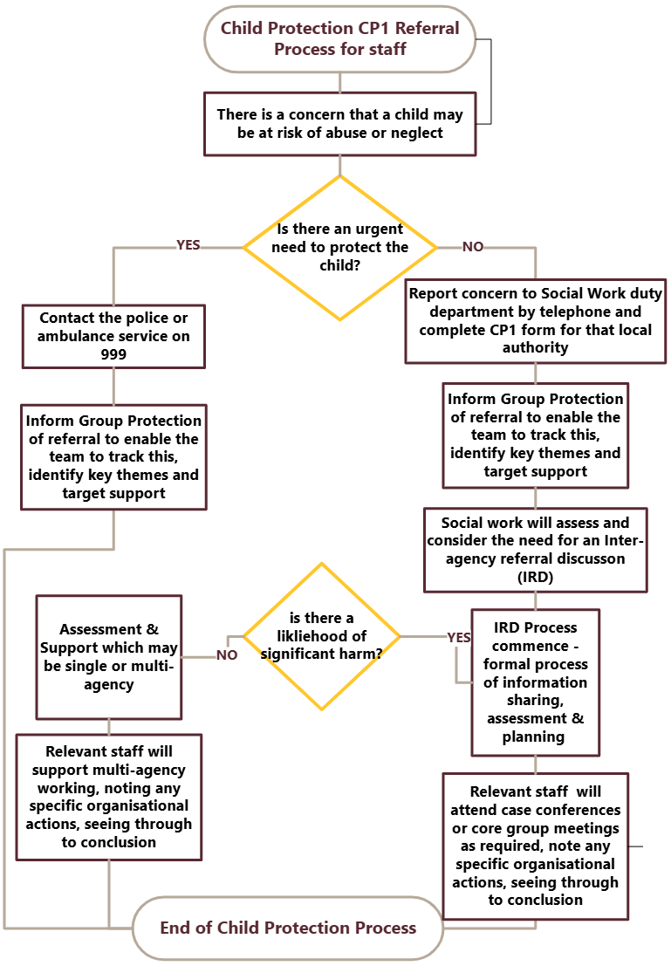

Appendix 2

Request for Assistance 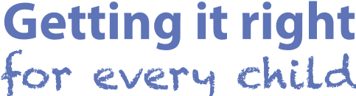

Is there an immediate child protection concern? If yes go straight to child protection procedures
Safeguarding Hub (MASH)
Please tick this box if you are identifying a ‘Wellbeing Need’.
1
.
Child’s Details
Name
Agency Unique
Identifier
Date of Birth/EDD
School
Address
Telephone
Number
Parents/Carer
Name
Parental Rights and
Responsibilities
Name of GP
Named Person
LAC Status
2. Form Completed By:
Name:
Designation/ Agency
Contact Details | Address:
Contact Details | Tel No: | Email:

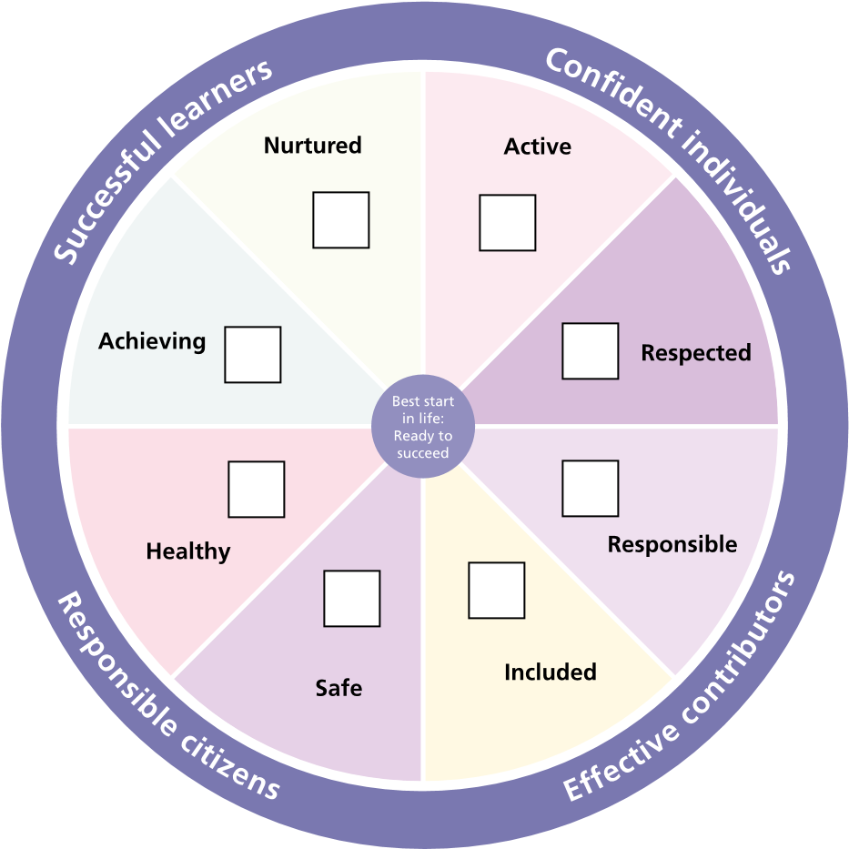
MAKE SURE THE WELLBEING INDICATORS THAT ARE CURRENTLY CAUSING CONCERN ARE HIGHLIGHTED
http://www.gov.scot/Topics/People/Young-People/
gettingitright/wellbeing

3. What Specifically Is The Concern?
4. How is this impacting on the child?
5. What assistance are you requesting?
6. What assessments/tools have you already undertaken to support your decision to request assistance? (what tools have you used)

7. What has your agency already done to help this child?
8. Full name/s of OTHER CHILDREN in the household, if known and significant to this request |  | DOB  (EDD if unborn) | Relationship to the child
9. Information Sharing. The family should have been informed of this Request for Assistance
Please record any relevant views from the child/ Parent/ Carer
Has consent been given by the Parent/Child/Carer for this Request? |  |  |  |  |  | Yes |  | No
If not, why not?
Is the Named Person aware of this Request for Assistance? |  |  |  |  |  | Yes |  | No
If no, why not?
10. Form Sent To:
Name: |  |  |  | Agency:
Date & Time:
Signature |  |  |  | Date

